OPTICAL SPECTROSCOPY OF PLASMA INDUCED BY IRRADIATION OF ANIMAL BONE WITH TEA CO₂ LASER

M. Marković¹, D. Ranković¹, M. Savić Biserčić², M.Trtica², J. Savović² and M. Kuzmanović¹

¹ University of Belgrade, Faculty of Physical Chemistry, Strudentski Trg 12-16, 11000 Belgrade, Serbia. (miroslav@ffh.bg.ac.rs)
² University of Belgrade, INN Vinca, Mike Petrovića Alasa 12-14, 11001 Belgrade, Serbia.

ABSTRACT
The application of laser-induced breakdown spectroscopy (LIBS) for the elemental analysis of pig shoulder bone samples is reported. Measurements were performed using a compact laboratory-made TEA CO₂ laser with low pulse energy. The recorded spectra consisted of well-defined lines of atoms and single charged ions of Ca, Mg, P, and other constituent elements, with a good signal-to-noise ratio suitable for spectrochemical analysis. Based on the ICP quantitative analysis of the bone sample, the limits of detection of LIBS analysis were estimated for Mg (16 ppm) and Na (940 ppm). Plasma parameters, temperature, and electron number density were determined by measuring Stark widths and relative intensities of the C and Mg ionic and atomic spectral lines.

INTRODUCTION
In forensic and archeological contexts, identifying isolated or fragmentary bones is essential since many non-osseous materials, like plastic, wood, or stones, can be mistaken for human/animal bone. Bones can be generally identified on three levels: gross skeletal anatomy, bone macrostructure, and bone histology (microstructure).
As a versatile, non-contact, multi-elemental, non-destructive sampling, powerful atomic spectrometry method LIBS provides elemental composition data of practically any forensic sample. LIBS utilizes a high power density laser pulse to ablate a sample and create a localized plasma plume. Plasma plume emits wavelengths characteristic of the elemental composition of the investigated sample.
TEA CO₂ laser has several advantages over the most common commercially used laser in LIBS, Nd:YAG laser. Unlike Nd:YAG laser, TEA CO₂ laser does much less damage to samples which is a benefit in applications such as forensics, archeology, or art where tolerance to damage and sample consumption is minimal. Its temporal pulse profile of the order of hundred nanoseconds, followed by a few μs tail, produces a plasma plume with good analytical characteristics.
In this work, a TEA CO₂ laser-based LIBS was applied for qualitative analysis of the elemental composition of a pig shoulder bone to demonstrate LIBS potential for relatively simple, fast, and sensitive analysis of complex organic matrices such as bones. The selection of a pig bone was based on its likeness with the human bones, i.e., only minor bone composition differences [1].

EXPERIMENTAL
The Transversely Excited Atmospheric pressure carbon dioxide (TEA CO₂) laser, developed at the VINCA Institute of Nuclear Sciences, was used as the radiation source in the applied LIBS setup [2]. The operating laser wavelengths were 10.5709 and 10.5909 μm, and the pulse repetition rate up to 2 Hz when in a multimode regime. The initial laser peak, which lasted around ~100 ns, carried approximately 35% of the total pulse energy. The initial peak was followed by a decaying tail which lasted around ~ 2 μs.
The optimized measurement parameters were: laser pulse energy of 155 mJ, laser beam focused at the sample surface, acquisition of plasma emission from a plasma slice 1 mm above the sample surface. ZnSe lens was used for laser beam focusing. A plasma image was projected on the entrance slit of a Carl Zeiss PGS2 spectrograph by an achromatic quartz lens. U2C-16H11850 CCD camera with enhanced sensitivity in UV range was used to capture plasma emission spectra. The CCD camera was triggered at a minimal exposure time of 10 ms to reduce dark current and noise. A preliminary quantitative analysis of samples was performed using the ICP OES technique (iCAP 6000, Thermo Scientific).

Results and Discussion
Part of the spectrum obtained by irradiating the bone sample with TEA CO₂ laser pulses is shown in Fig. 1. In the spectral region around 250 nm, atomic and ionic carbon lines and strong atomic phosphorus lines dominate the spectrum. In addition, oxygen and nitrogen ion lines from the atmosphere were observed in the spectrum.
The measurement of the ionic to atomic carbon line intensity ratio is a very suitable method for determining the ionic temperature (T_{ion}) in plasma [3]. Determination of temperature using the C II/C I intensity ratio required knowledge of the electron concentration, N_{e}. The electron number density was determined from the Stark-broadened profile of the C I 247.86 nm line. The experimental line profile was deconvolved to extract Lorentz width, assuming that the Stark broadening dominates the Lorentz profile. The Gaussian component of the profile was fixed to the predetermined instrumental width (0.040 nm). The Stark width of carbon 247.86 nm line was 0.024 nm which corresponds to the electron number density of 2.9×10¹⁷ cm⁻³ [4]. The ionic temperature of T_{ion} =18100 K was calculated from the measured intensity ratio of C II 250.91 nm and C I 247.86 nm lines (0.077) and the predetermined value of N_{e}.

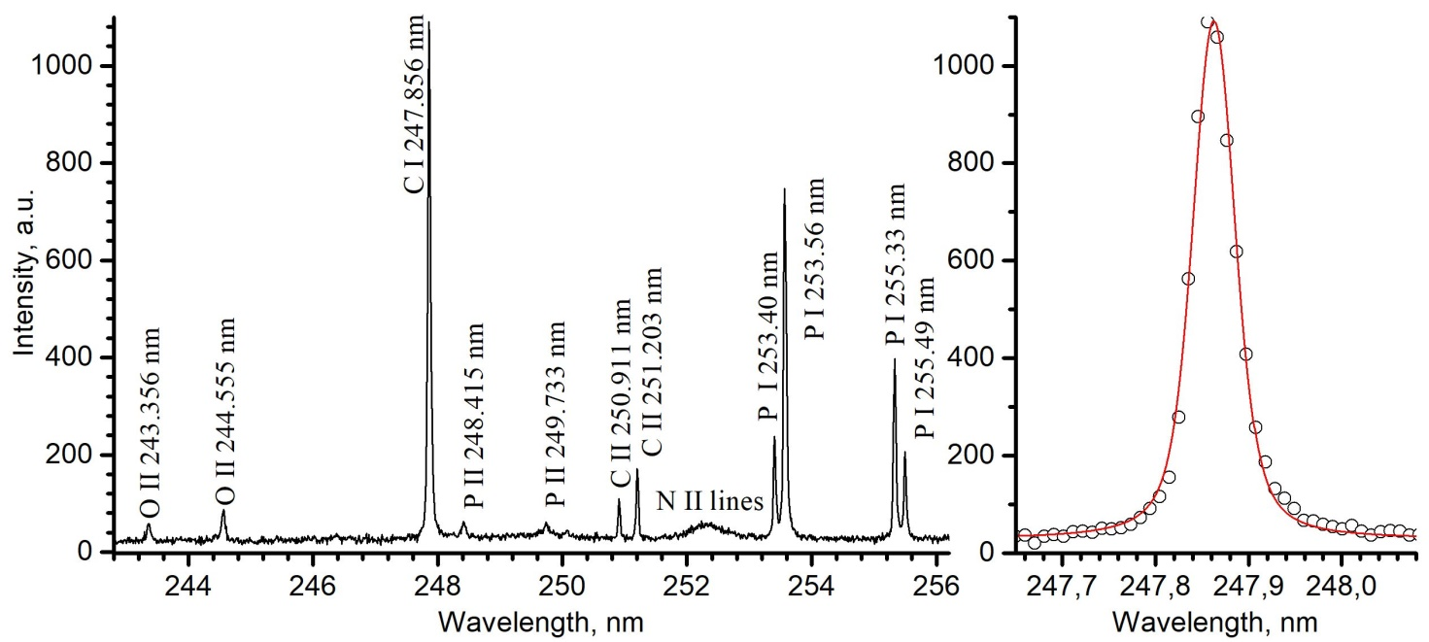

Figure 1. a) Part of UV spectra of the pig shoulder bone sample, b) Profile of C I 247.856 nm line fitted with Voit profile (fixed Gaussian width of 0.040 nm)

An intense C I line at 247.86 nm is suitable for the determination of the carbon concentration. Using the measured intensity to background noise ratio of the carbon line and assuming the typical carbon concentration in bones (mainly in the form of CaCO₃) is about 5%, the detection limit (LOD) for carbon was estimated at 0.07%. Similarly, using the Na I line 330.23 nm line, LOD for sodium was estimated at 940 ppm. Despite a low sensitivity, this line is still usable for detecting Na in samples with larger quantities of this element, as our bone sample (4330 ppm). The Na I line at 588.00 nm is suitable to determine Na with higher sensitivity, but only in samples with low Na concentrations since this line is highly prone to self-absorption.

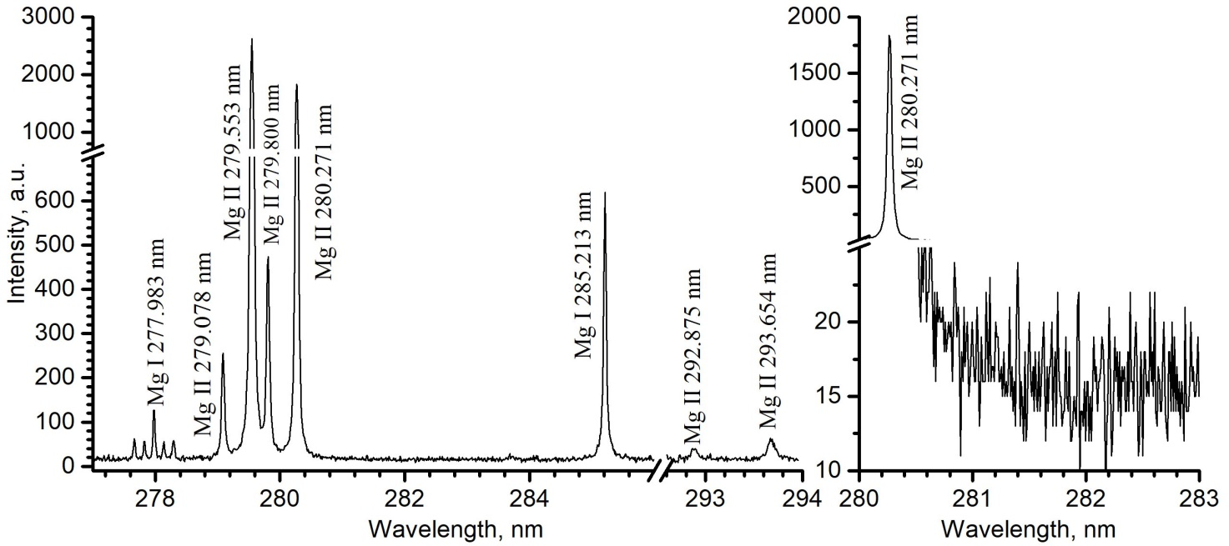

Figure 2. a) Part of LIBS spectra of the pig shoulder bone sample: Mg I and Mg II lines, b) Illustration of the determination of LOD for magnesium.

In Fig. 2a, a group of magnesium ionic and atomic lines suitable for plasma diagnostics is shown. Using the predetermined electron concentration, from the ratio of Mg II 280.27 nm and Mg I 285.21 nm line integral intensities [5], the ionization temperature of 10500 K was calculated. The difference in temperatures determined from carbon and magnesium lines is caused by the fact that the predominant emission of these lines comes from different plasma regions. Due to the significantly higher ionization and excitation energy of carbon regarding magnesium, the maximum carbon emission is located in the hotter plasma zones. The lines shown in Fig. 2 are also suitable for determining the magnesium content. Magnesium is present in the bones in a significant concentration, e.g., the Mg concentration in our sample was 0.344%. Figure 2b illustrates the determination of LOD using the Mg II ionic line at 280.27 nm. The obtained LOD for Mg was 16 ppm.

CONCLUSION
The applicability of the LIBS technique based on low pulse energy TEA CO₂ laser for the elemental analysis of bone samples was demonstrated. LIBS can be used to detect most metals in bones with detection limits between 10-100 ppm, as illustrated by the Mg example. The possibility of using Mg and C lines for plasma diagnostics was also demonstrated. Apparent values for electron concentration of 2.9×10¹⁷ cm⁻³ and ionization temperature in the range from 10500 to 18100 K were determined, depending on the properties of the element whose lines were used for diagnostics.
Acknowledgement
This work was partially supported by the Ministry of Education, Science and Technological Development of the Republic of Serbia through Contract No. 451-03-68/2020-14/200146 and 451-03-9/2021-14/200017.

REFERENCES
[1] K. Franke, F. Schöne, A. Berk, M. Leiterer, G. Flachowsky, Eur. J. Nutr. 2008, 47, 40–46.
[2] M. Momcilovic, M. Kuzmanovic, D.Rankovic, J.Ciganovic, M.Stoiljkovic, J. Savovic, M. Trtica, Appl. Spectrosc. 2015, 69, 419-429.
[3] M. Kuzmanovic, D. Rankovic, M. Trtica, J. Ciganovic, J. Petrovic, J. Savovic, Spectrochim. Acta 2019, 157, 37-46.
[4] H. Griem, Spectral Line Broadening by Plasmas, Academic Press, New York, 1974.
[5] E. Tognoni, M. Hidalgo, A. Canals, G. Cristoforetti, S. Legnaioli, A. Salvetti, V. Palleschi, Spectrochim. Acta Part B 2007, 62, 435-443.

